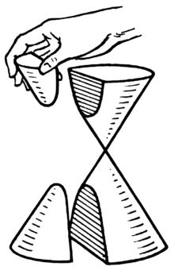
A hyperbola locus problem
Let the left and right vertices of the hyperbola $H: \frac{x^{2}}{3}-y^{2}=1$ be $A_{1}, A_{2}$.
Let $P\left(x_{1},y_{1}\right), Q\left(x_{1},{-y}_{1}\right)$ be two different movable points on the given hyperbola.
Let the intersection of $A_{1}P and A_{2}Q$ be M. Find the equation E of the locus of M.
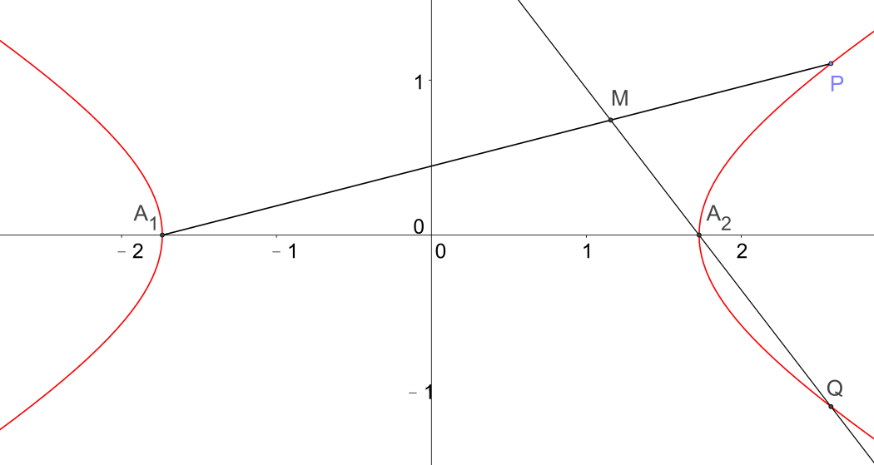
Method 1
From the question $\left|x_{1}\right|>3$ and $A_{1}\left(-\sqrt{3}, 0\right), A_{2}\left(\sqrt{3}, 0\right)$ .
$${PA}_{1}: y=\frac{y_{1}}{x_{1}+\sqrt{3}}\left(x+\sqrt{3}\right) ….(1)$$
$${QA}_{2}: y=\frac{{-y}_{1}}{x_{1}-\sqrt{3}}\left(x-\sqrt{3}\right) ….(2)$$
Solving, we get: $x=\frac{3}{x_{1}}, y=\frac{\sqrt{3}y_{1}}{x_{1}}$
Change of subjects, we get: $x_{1}=\frac{3}{x}, y_{1}=\frac{\sqrt{3}y}{x} ….(3)$
Then $x≠0, \left|x\right|<3$ .
Since $P\left(x_{1},y_{1}\right)$ is on the hyperbola : $\frac{x^{2}}{3}-y^{2}=1$ , we have $\frac{{x_{1}}^{2}}{3}-{y_{1}}^{2}=1 ….(4)$
$$\left(3\right)↓\left(4\right), E: \frac{x^{2}}{3}+y^{2}=1, x≠0, x≠±\sqrt{3}$$
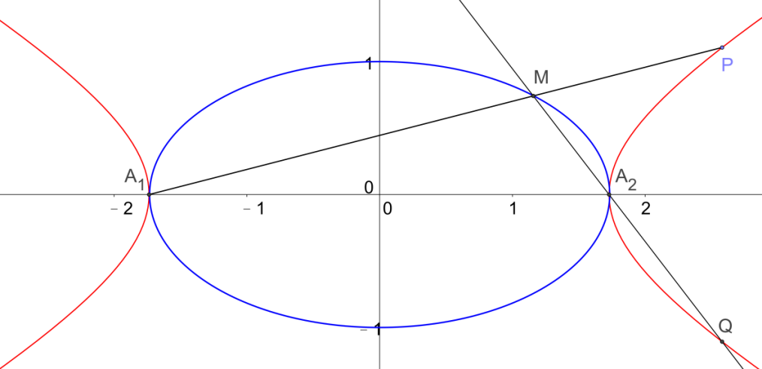
In the above, $x≠0, x≠±\sqrt{3}$ should be included in E. We can also get this by another way.

Assertion: $x≠0, x≠±\sqrt{3}$ in E.
P, Q are two different points on the given hyperbola, so they cannot coincide with $A_{1}{ and A}_{2}$.
Therefore $A_{1}{ and A}_{2}$ cannot be points in E and $x≠±\sqrt{3}$
Let L be the line joining $\left(0,1\right)$ and $A_{2}\left(\sqrt{3}, 0\right)$ .
Solving : $\left\{\begin{matrix}L: x+\sqrt{3}y-\sqrt{3}=0 \\ H: \frac{x^{2}}{3}-y^{2}=1\end{matrix}\right.$
We get $x=\sqrt{3}, y=0$ , Hence the only intersection point between L and H is $A_{2}\left(\sqrt{3}, 0\right)$.
Hence E cannot pass through $\left(0,1\right)$ .
Similarly E cannot pass through $\left(0,-1\right)$ .

Method 2
From the question $\left|x_{1}\right|>3$ and $A_{1}\left(-\sqrt{3}, 0\right), A_{2}\left(\sqrt{3}, 0\right)$ .
Let $M\left(x,y\right)$ be the intersection point of $A_{1}P and A_{2}Q$ .
$A_{1}, M, P$ are collinear, $\frac{y}{x+\sqrt{3}}=\frac{y_{1}}{x_{1}+\sqrt{3}} ….(5)$
$A_{2}, M, Q$ are collinear, $\frac{y}{x-\sqrt{3}}=\frac{-y_{1}}{x_{1}-\sqrt{3}} ….(6)$
$(5)×(6)$, $\frac{y^{2}}{x^{2}-3}=\frac{{-y_{1}}^{2}}{{x_{1}}^{2}-3} ….(7)$
Since $P\left(x_{1},y_{1}\right)$ is on the hyperbola : $\frac{x^{2}}{3}-y^{2}=1$ , we have $\frac{{x_{1}}^{2}}{3}-{y_{1}}^{2}=1$.
$-{y_{1}}^{2}=1-\frac{{x_{1}}^{2}}{3} ….(8)$
$$\left(8\right)↓\left(7\right), E: \frac{x^{2}}{3}+y^{2}=1$$
By the Assertion , $x≠0, x≠±\sqrt{3}$ .

Further point of interest for you to try :
Let the left and right vertices of the ellipse $E: \frac{x^{2}}{3}-y^{2}=1$ be $A_{1}, A_{2}$.
Let $P\left(x_{1},y_{1}\right), Q\left(x_{1},{-y}_{1}\right)$ be two different movable points on the given ellipse.
Let the intersection of $A_{1}P and A_{2}Q$ be M. Find the equation H of the locus of M.

